**ASSIGNMENT**

1. UML class diagram on airline reservation system.

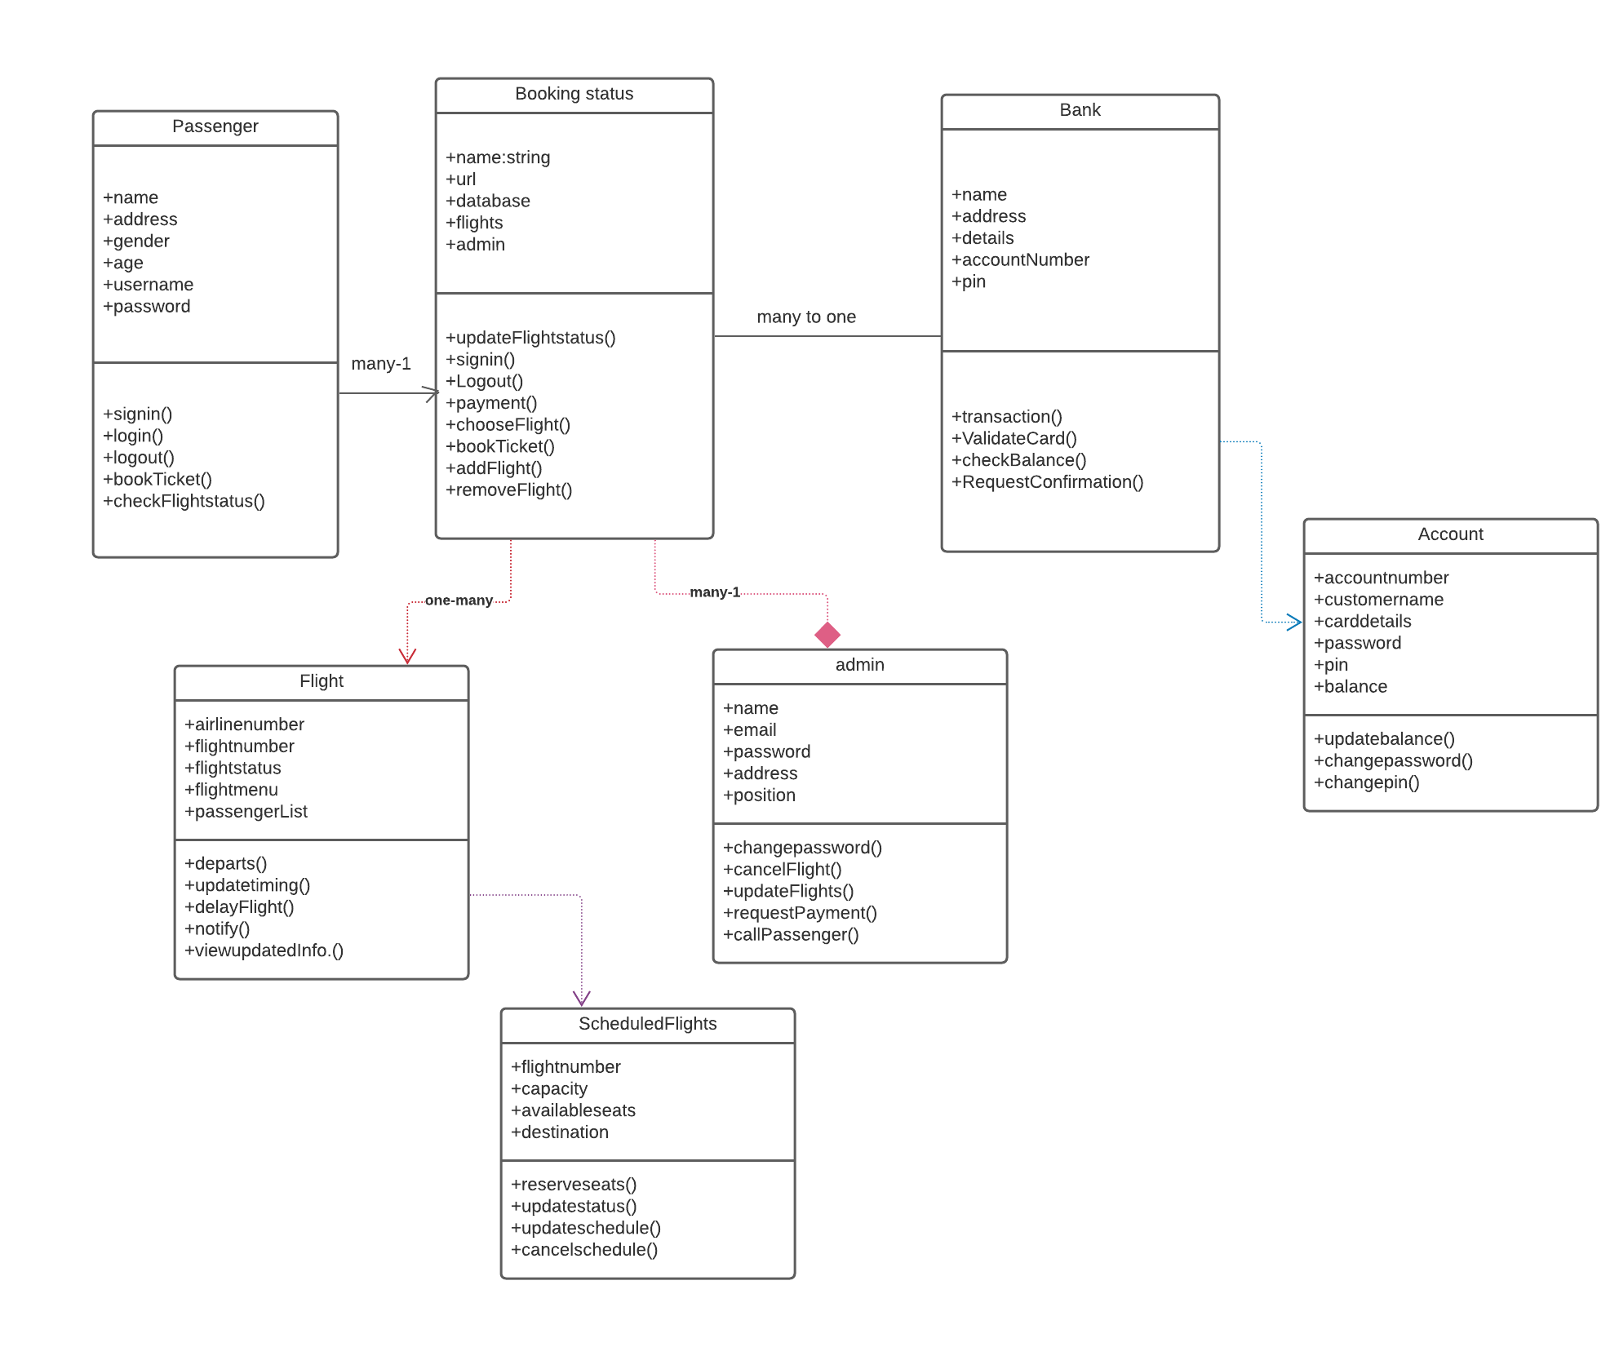

1. UML class diagram on university management system

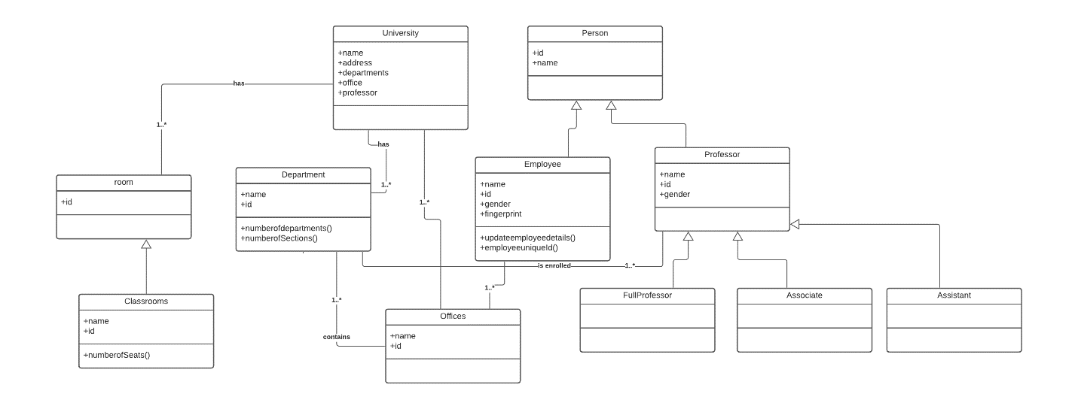

1. Activity diagram where student needs to enroll with the university for the given course.

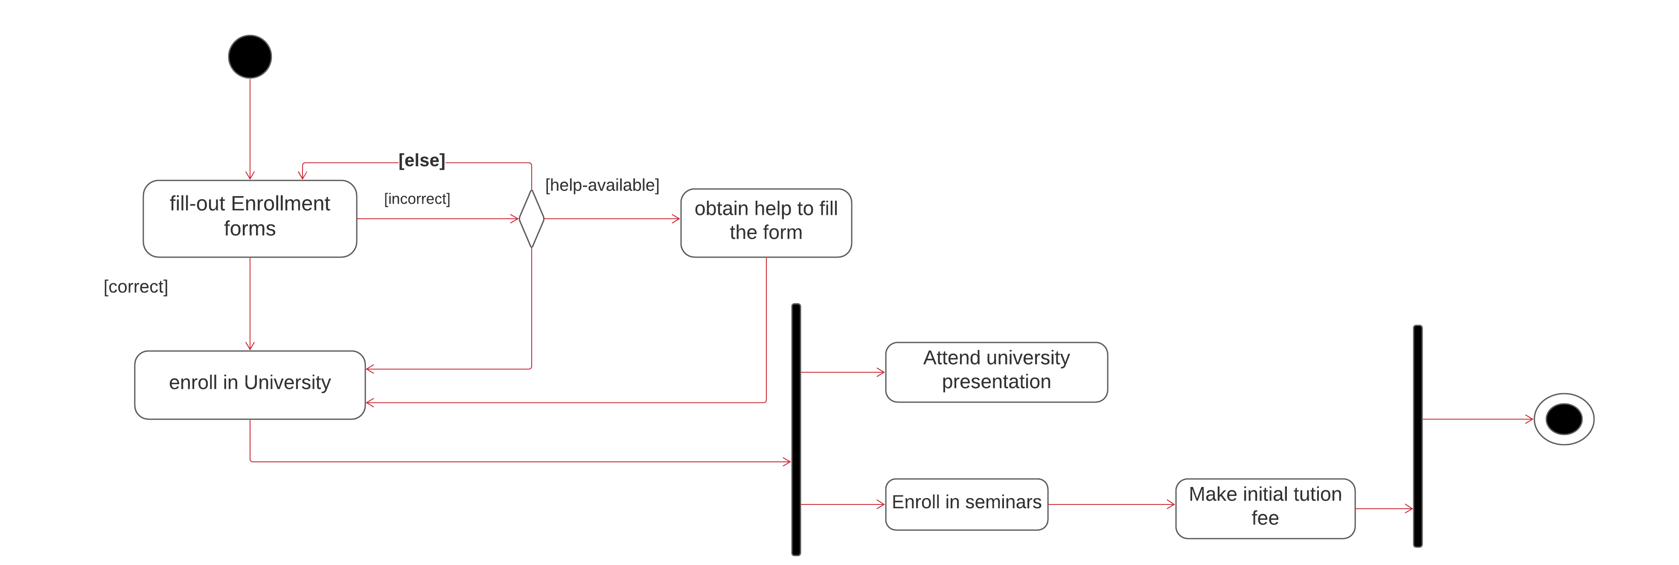

1. Sequence diagram for online library management system.

